Program 9: (Dataflow Testing for commission calculation)
Design, develop, code and run the program in any suitable language to solve the
commission problem. Analyze it from the perspective of dataflow testing, derive
different test cases, execute these test cases and discuss the test results.

- //Program 9: (Dataflow Testing for commission calculation)
- #include<stdio.h>
- int main()
- {
- int locks, stocks, barrels, tlocks, tstocks, tbarrels;
- float lprice,sprice,bprice,lsales,ssales,bsales,sales,comm;
- lprice=45.0;
- sprice=30.0;
- bprice=25.0;
- tlocks=0;
- tstocks=0;
- tbarrels=0;
- printf("\nenter the number of locks and to exit the loop enter -1 for locks\n"); scanf("%d", &locks);
- while(locks!=-1) {
- printf("enter the number of stocks and barrels\n"); scanf("%d%d",&stocks,&barrels);
- tlocks=tlocks+locks;
- tstocks=tstocks+stocks;
- tbarrels=btarrels+barrels;
- printf("\nenter the number of locks and to exit the loop enter -1 for locks\n"); scanf("%d",&locks);
- }
- printf("\ntotal locks = %d\”,tlocks);
- printf(“total stocks =%d\n”,tstocks);
- printf(“total barrels =%d\n",tbarrels);
- lsales = lprice*tlocks;
- ssales=sprice*tstocks;
- bsales=bprice*tbarrels;
- sales=lsales+ssales+bsales;
- printf("\nthe total sales=%f\n",sales);
- if(sales > 1800.0)
- {
- comm=0.10*1000.0;
- comm=comm+0.15*800;
- comm=comm+0.20*(sales-1800.0);
}
- else if(sales > 1000)
- {
- comm =0.10*1000;
- comm=comm+0.15*(sales-1000);
}
- else
- comm=0.10*sales;
- printf("the commission is=%f\n",comm);
- return 0;
- }
Test Case Name : Data Flow Testing for Commission Program
Experiment No : 9
Precondition : Enter -1 for locks to exit from input loop
Brief Description : Enter the locks, stocks and barrels > 0
Define /Use nodes for variables in the commission problem
Variable name | Defined at node | Used at Node
lprice | 7 | 24
sprice | 8 | 25
bprice | 9 | 26
tlocks | 10,16 | 16,21,24
tstocks | 11,17 | 17,22,25
tbarrels | 12,18 | 18,23,26
locks | 13,19 | 14,16
stocks | 15 | 17
barrels | 15 | 18
lsales | 24 | 27
ssales | 25 | 27
bsales | 26 | 27
sales | 27 | 28,29,33,34,37,39
comm | 31,32,33,36,37,39 | 32,33,37,40

Selected Define/Use Paths for Commission problem
Test case id | Description | Variables Path (Beginning, End nodes) | Du Paths | Definition clear? | Comments
1 | Check for lock price variable DEF(lprice,7) and USE(lprice,24) | (7 , 24) | <7-8-9-10-11-12-13-14-15-16-17-18-19-20-21-22-23-24> | Yes
2 | Check for Stock price variable DEF(sprice,8) and USE(sprice,25) | (8 , 25) | <8-9-10-11-12-13-14-15-16-17-18-19-20-21-22-23-24-25> | Yes
3 | Check for barrel price variable DEF(bprice,9) and USE(bprice,26) | (9 , 26) | <9-10-11-12-13-14-15-16-17-18-19-20-21-22-23-24-25-26> | Yes
4 | Check for total locks variable DEF((tlocks,10) and DEF(tlocks,16)) and 3 usage node(USE(tlocks,16),USE(tlocks,21),  USE(tlocks,24) | (10 , 16) | <10-11-12-13-14-15-16> | Yes
4 |  | (10 , 21) | <10-11-12-13-14-15-16-17-18-19-20-14-21> | No
4 |  | (10 , 24) | <10-11-12-13-14-15-16-17-18-19-20-14-21-22-23-24> | No
4 |  | (16 , 16) | <16-16> | Yes
4 |  | (16 , 21) | <16-17-18-19-20-14-21> | No
4 |  | (16 , 24) | <16-17-18-19-20-14-21-22-23-24> | No
5 | Check for total stocks variable DEF((tstocks,11) and DEF(tstocks,17)) and 3 usage node(USE(tstocks,17),USE(tstocks,22),USE(tstocks,25) | (11 , 17) | <11-12-13-14-15-16-17> | Yes
5 |  | (11 , 22) | <11-12-13-14-15-16-17-18-19-20-21-14-21> | No
5 |  | (11, 25) | <11-12-13-14-15-16-17-18-19-20-21-14-21-23-24-25> | No
5 |  | (17 , 17) | <17-17> | Yes
5 |  | (17 , 22) | <17-18-19-20-14-21-22> | No
5 |  | (17 , 25) | <17-18-19-20-14-21-22-23-24-25> | No
6 | check for locks variable ( DEF(locks,13), DEF(locks,19) and USE(locks,14),USE(locks,16) | (13 , 14) | <13-14> | Yes | Begin the loop
6 |  | ( 13 , 16) | <13-14-15-16> | Yes
6 |  | (19 , 14) | <19-20-14> | Yes
6 |  | (19 , 16) | <19-20-14-15-16> | Yes | Repeat the loop
7 | Check for stocks variable (DEF(stocks,15) and USE(stocks,17) | (15 , 17) | <15-16-17> | Yes
8 | Check for sales DEF(sales, 27) and USE(Sales, 28), USE(Sales , 29), USE(Sales,33) , USE(Sales , 34) , USE(Sales,37) , USE(Sales , 39) | (27 ,28) | <27-28> | Yes
8 |  | (27 , 29) | <27-28-29> | Yes
8 |  | (27 , 33) | <27-28-29-30-31-32-33> | Yes
8 |  | (27 , 34) | <27-28-29-34> | Yes
8 |  | (27 , 37) | <27-28-29-34-35-36-37> | Yes
8 |  | (27 , 39) | <27-28-29-34-38-39> | Yes
9 | Check for Commission variable DEF(comm, 31,32,33) , DEF(comm,34,35) and DEF(comm,39) and USE(comm,42) | ( (31,32,33),40) | <31-32-33-40> | Yes
9 |  | ((34 , 35) , 40) | <34-35-40> | Yes
9 |  | ((39 , 40) | <39 - 40> | Yes

Program 10 (Binary Search - Path Testing)

Design, develop a code and run the program in any suitable language to implement the binary search algorithm. Determine the basis paths and using them derive different test cases execute these test cases and discuss the test results

#include<stdio.h>
int binsrc(int x[],int low,int high,int key)
{
int mid;
while(low<=high)
{
mid=(low+high)/2;
if(x[mid]==key)
return mid;
if(x[mid]<key)
low=mid+1;
else
high=mid-1;
}
return -1;
}

int main()
{
int a[20],key,i,n,succ;
printf("Enter the n value");
scanf("%d",&n);
if(n>0)
{
printf("enter the elements in ascending order\n");
for(i=0;i<n;i++)
scanf("%d",&a[i]);

printf("enter the key element to be searched\n");
scanf("%d",&key);
succ=binsrc(a,0,n-1,key);
if(succ>=0)
printf("Element found in position = %d\n",succ+1);
else
printf("Element not found \n");
}
else
printf("Number of element should be greater than zero\n");
return 0;
}

Binary Search function with line number

int binsrc(int x[],int low, int high, int key)
{
int mid; 1
while(low<=high) 2
{
mid=(low+high)/2;
if(x[mid]==key) 3
return mid; 8
if(x[mid]<key) 4
low=mid+1; 5
else
high=mid-1; 6
} 7
return -1; 8
} 9

Program Graph – for Binary Search

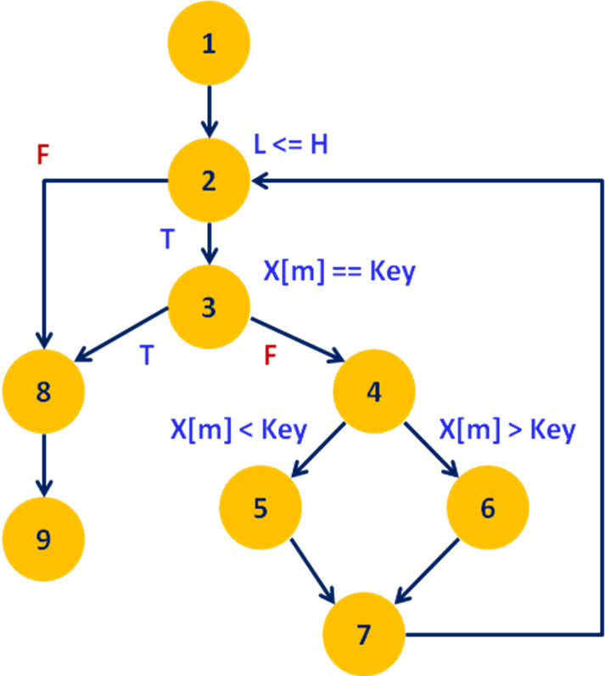
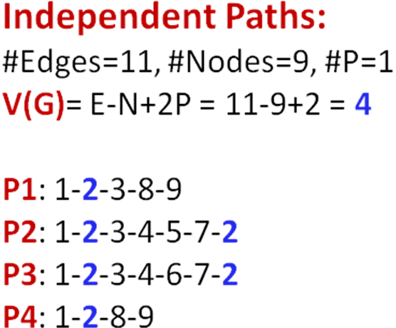

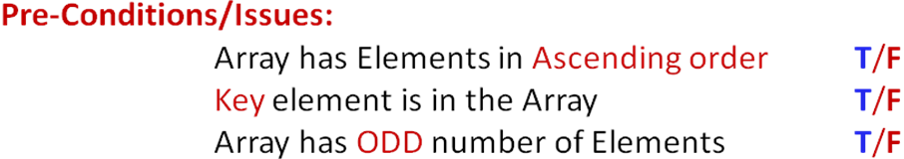

Test Cases – Binary Search

Case Id | Paths | Inputs |  |  | Expected Output | Actual Output | Status
Case Id | Paths | value of n | x[] | key | Expected Output | Actual Output | Status
1 | P1: 1-2-3-8-9 | 5 | {10,20,30,40,50} | 30 | Key element found at position 3
2 | P2: 1-2-3-4-5-7-2 | 5 | {10,20,30,40,50} | 40 | Key element found at position 4
3 | P3: 1-2-3-4-6-7-2 | 5 | {10,20,30,40,50} | 10 | Key element found at position 1
4 | P4: 1-2-8-9 | 5 | {10,20,30,40,50} | 60 OR 05 | Key element not found

Program 11 (Quick Sort-Path Testing)

Design, develop, code and run the program in any suitable language to implement the Quick-Sort Algorithm. Determine the basis paths and using them derive different test cases, execute these test cases and discuss the test results.

#include<stdio.h>
void quicksort(int x[10],int first,int last)
{
int temp,pivot,i,j;
if(first<last)
{
pivot=first;
i=first;
j=last;
while(i<j)
{
while(x[i]<=x[pivot] && i<last)
i++;
while(x[j]>x[pivot])
j--;
if(i<j)
{
temp=x[i];
x[i]=x[j];
x[j]=temp;
}
}
temp=x[pivot];
x[pivot]=x[j];
x[j]=temp;
quicksort(x,first,j-1);
quicksort(x,j+1,last);
}
}

// main program

int main()
{
int a[20],i,key,n;
printf("enter the size of the array");
scanf("%d",&n);
if(n>0)
{
printf("enter the elements of the array");
for(i=0;i<n;i++)
scanf("%d",&a[i]);

quicksort(a,0,n-1);
printf("the elements in the sorted array is:\n");
for(i=0;i<n;i++)
printf("%d\t",a[i]);
}
else
{
printf(“size of array is invalid\n”);
}

Quick sort function with line number

void quicksort(int x[10],int first,int last)
{
int temp,pivot,i,j; 1
if(first<last) 2
{
pivot=first; 3
i=first; 4
j=last; 5
while(i<j) 6
{
while(x[i]<=x[pivot] && i<last) 7
i++; 8
while(x[j]>x[pivot]) 9
j--; 10
if(i<j) 11
{
temp=x[i]; 12
x[i]=x[j]; 13
x[j]=temp; 14
}
}
temp=x[pivot]; 15
x[pivot]=x[j]; 16
x[j]=temp; 17
quicksort(x,first,j-1); 18
quicksort(x,j+1,last); 19
}
} 20

Program Graph – Quick Sort

A
C
D
B
E
F
G
N
J
first < last
F
i < j
Right Scan
Left Scan
T
F
T
Initialization
H
T
T
F
F
I
K
i<j
T
F
M
Recursive Calls

Independent Paths– Quick Sort
P1: A-B-N
Independent Paths:
#Edges=18, #Nodes=13, #P=1
V(G)= E-N+2P = 18-13+2 = 7
P2: A-B-C-J-K-B
P3: A-B-C-J-K-M-B
P4: A-B-C-D-F-H-C
P5: A-B-C-D-F-H-I-C
P6: A-B-C-D-E-D-F-H
P7: A-B-C-D-F-G-F-H

Pre-Conditions/Issues:
Array has only one Element, Two Elements, Three Elements (6 Possibilities)
Array has Elements in ASC/DSC/Arbitrary( Any of the Permutations)
EX: 3 elements: 123, 132, 213, 231, 312, 321, 222,111,333

Test Cases – Quick Sort

